**Web Programming Project**

This portal is dedicated to our department and serves as an individual platform for students. Through this portal, students can access daily updates, track class schedules, upcoming exams, and class tests (CTs), view their exam results, and access daily lectures and academic materials. It is designed to streamline academic communication and enhance student engagement with departmental activities.

Resources and Reference:

1. <https://www.sportal.nstu.ac.bd/>

2. <https://www.bracu.ac.bd/students>

**This will be the Homepage**

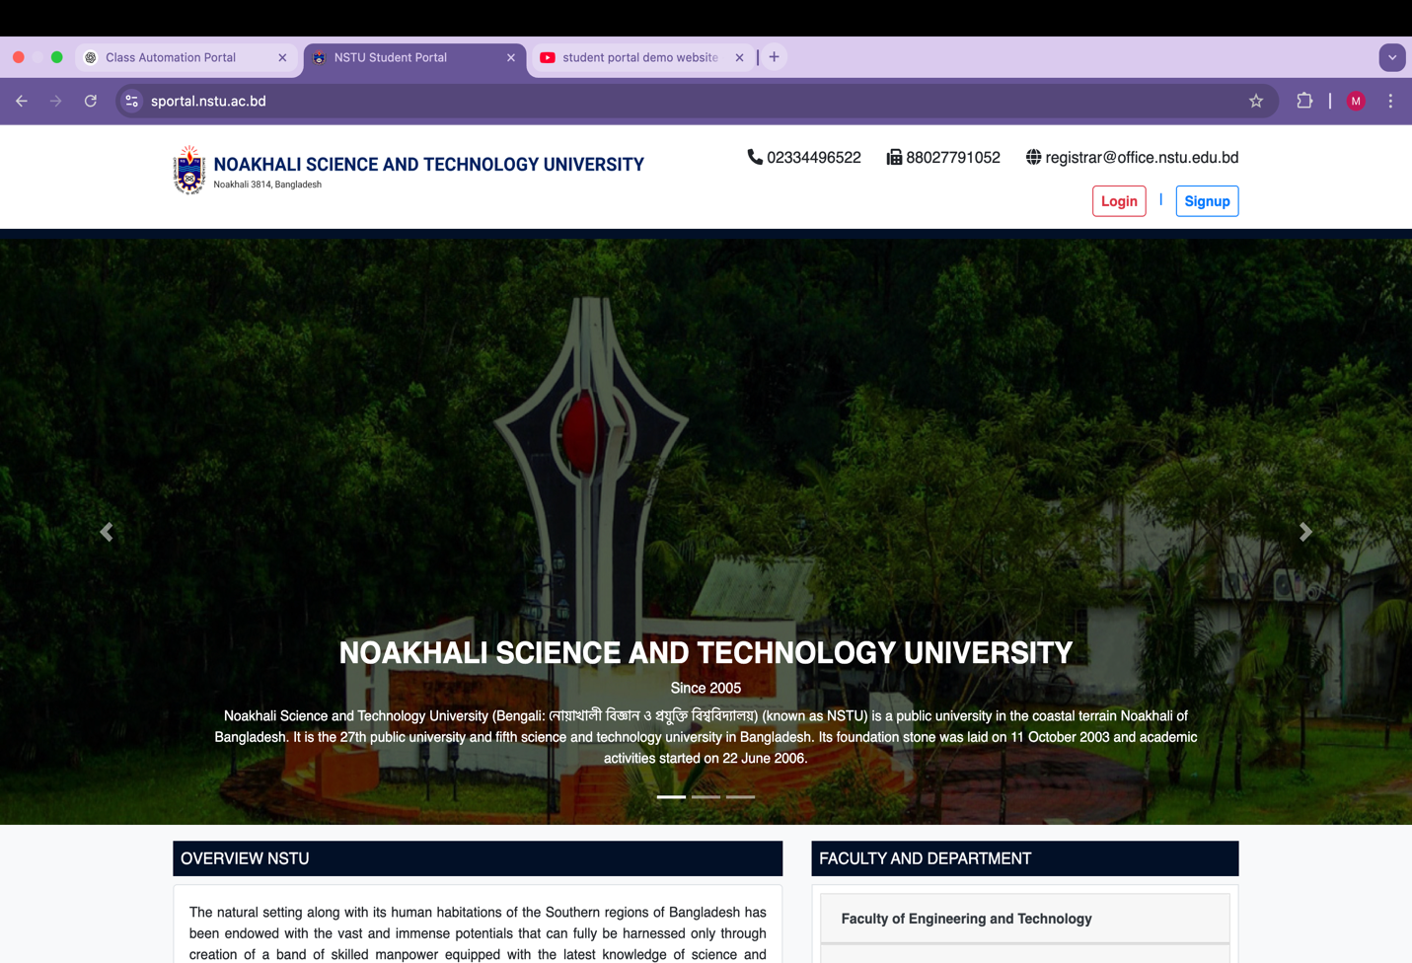

When scroll down this homepage there will be a section where it’ll be written about this Portal:

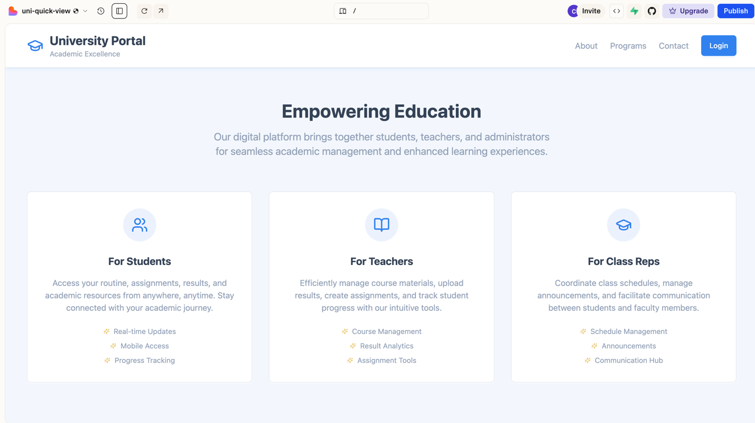

**Footer :**

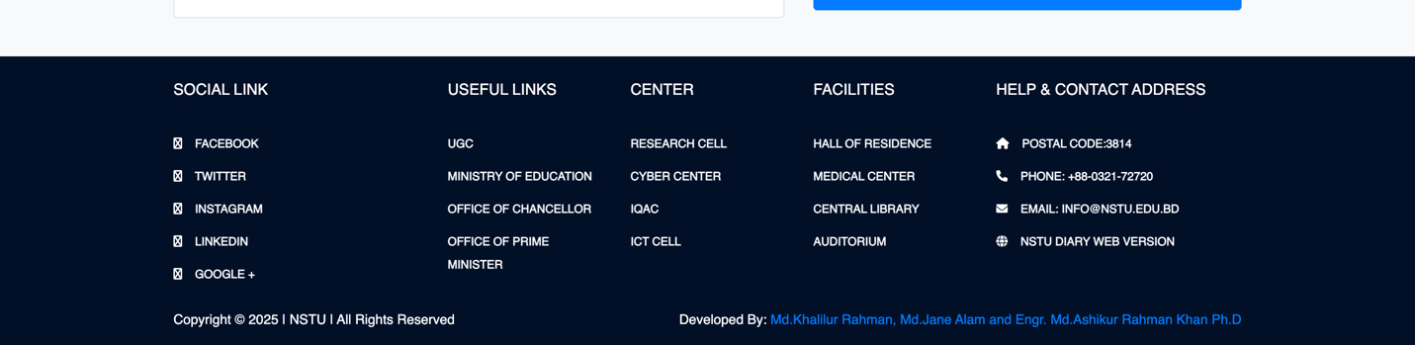

In the overview, there will be written about our department and in the faculty and department option there will be information about our faculty members and Staff members informations,

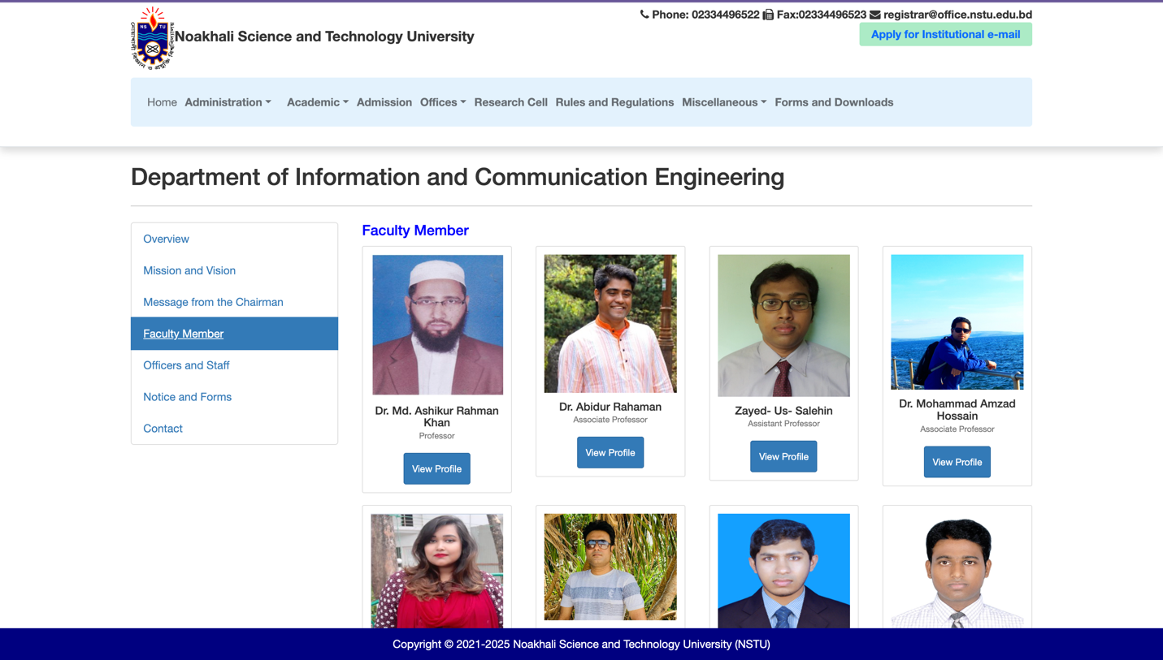

There will be a **Sign-Up page** where **students can register publicly.** However, **teachers will not sign up themselves** their information will be **manually added to the database by the admin**. Therefore, **teachers only need to log in** to access the portal.

**Sign up page:**

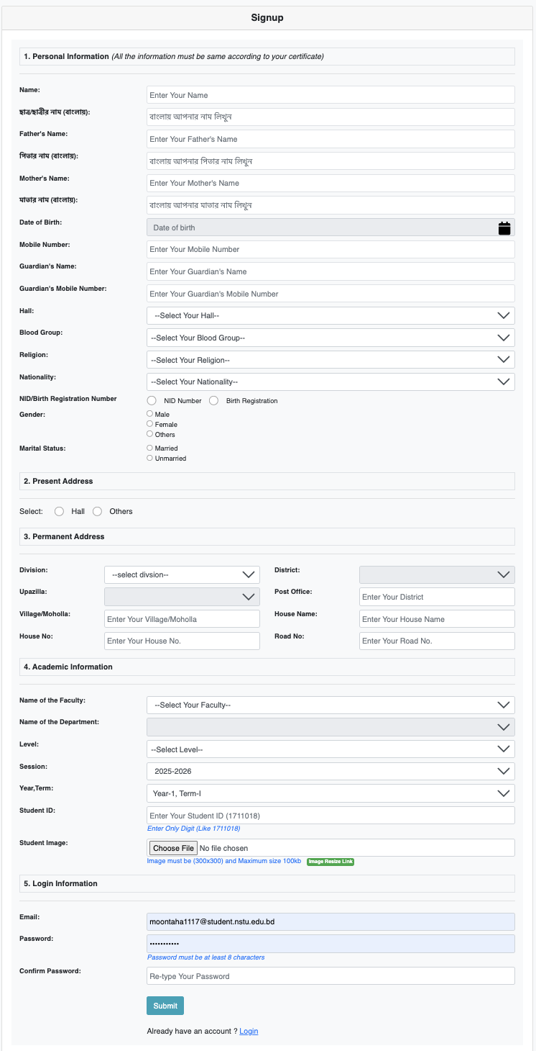

There will be different login section for teacher, CR and Students

**After clicking in Login:**

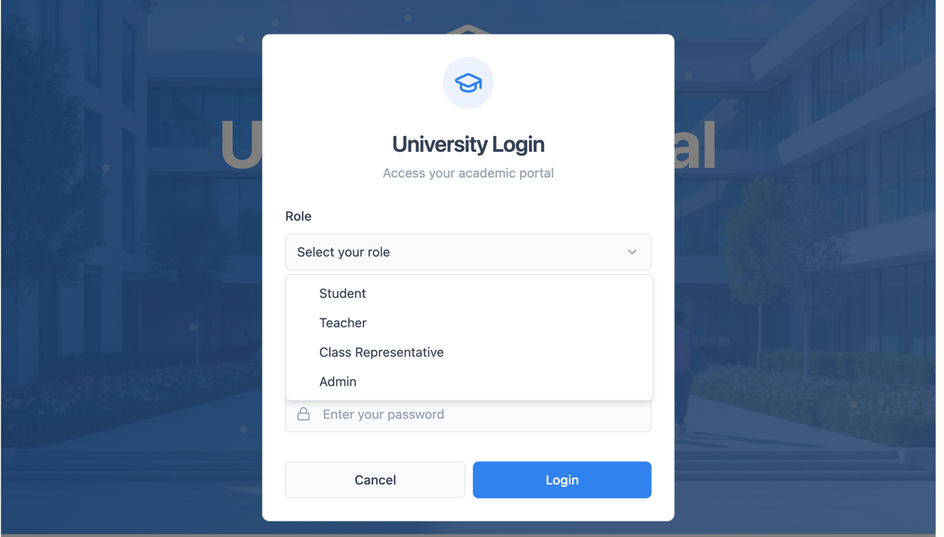

**If forgot password:**

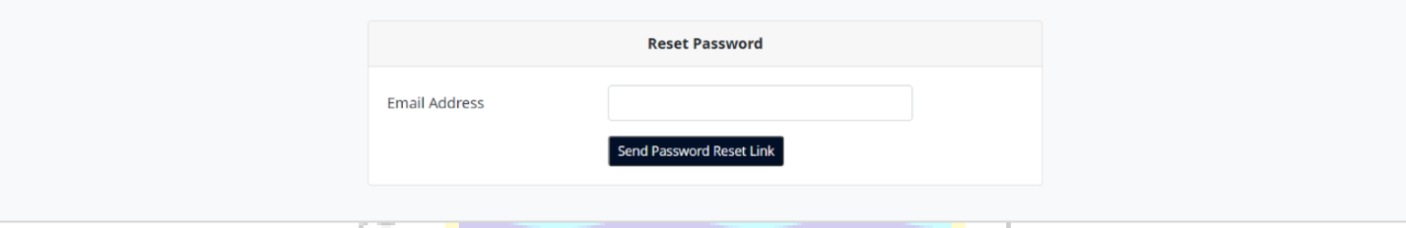

After login as a Student there will be a dashboard for student from where student can see the updates about class, ct, result everything

**Student dashboard:**

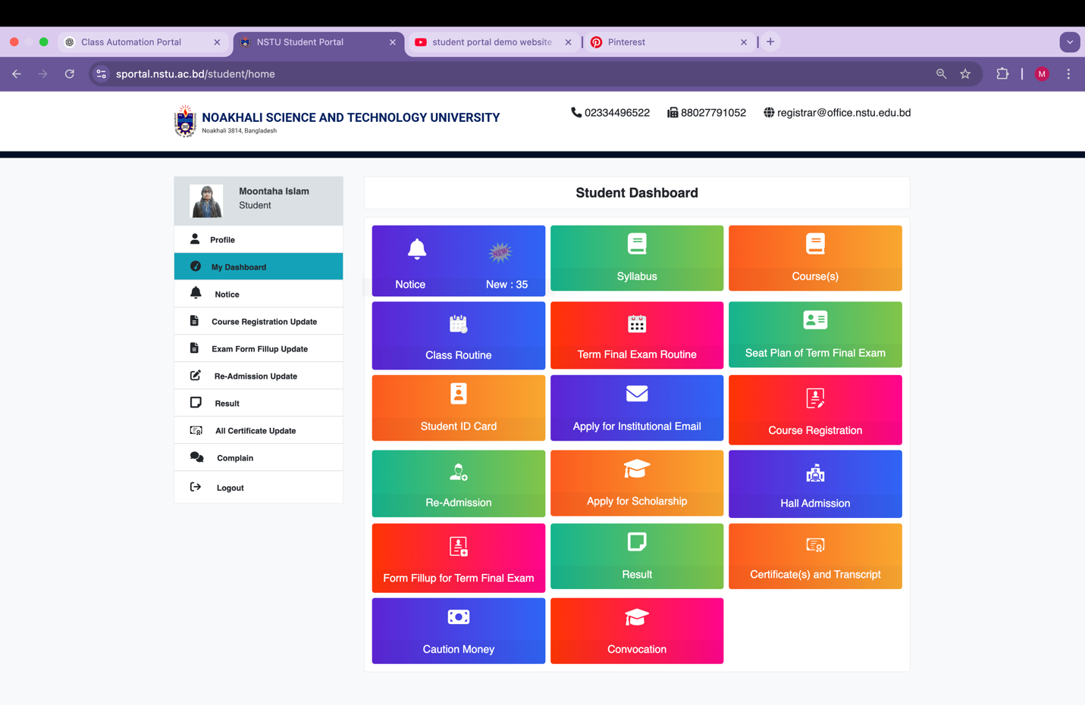

After login as a teacher there will be option to choose session and semester :

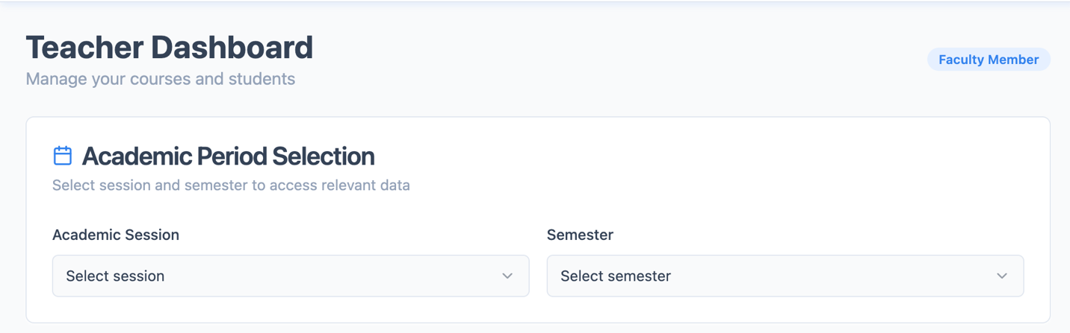

**Teacher’s Dashboard:**

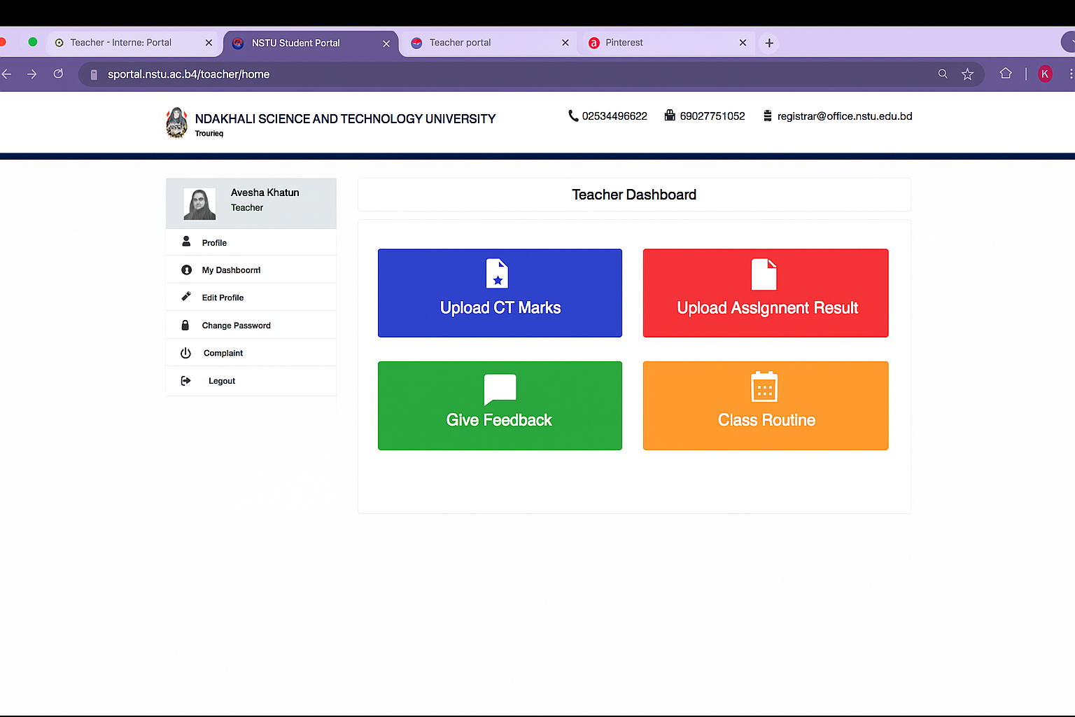

In the CR’s section there will be also a option of selecting Session and semester:

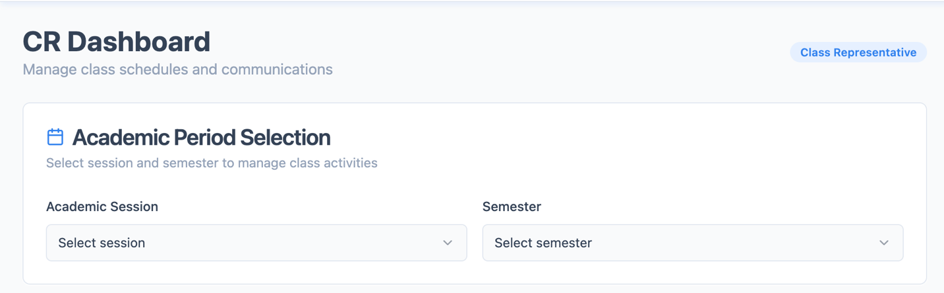

**CR’s dashboard:**

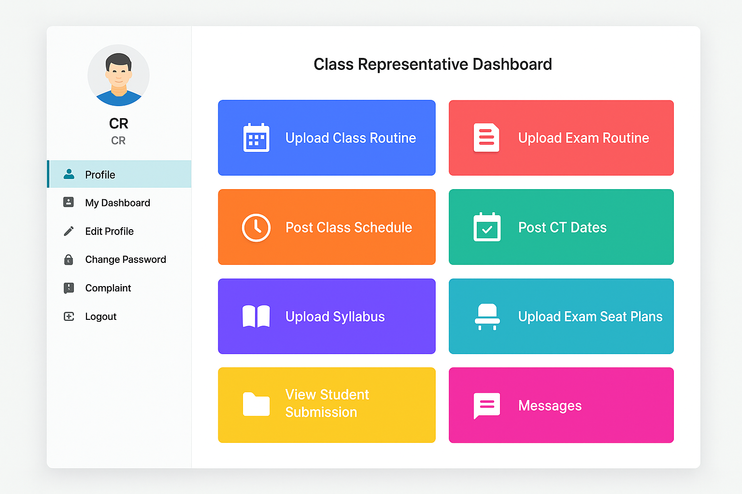

**How to see CT results from student dashboard**

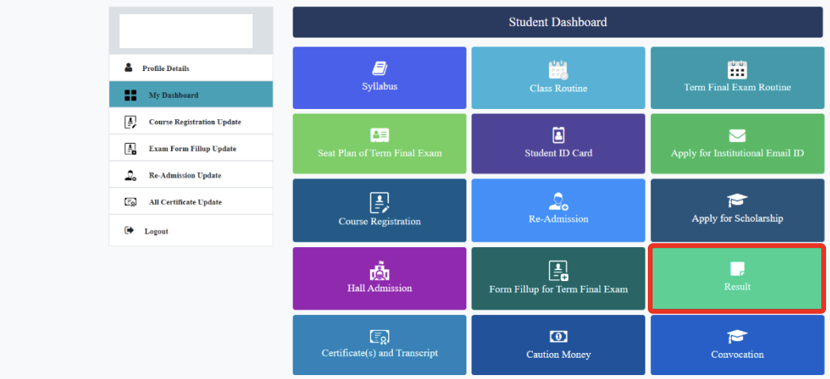

Then this page will show

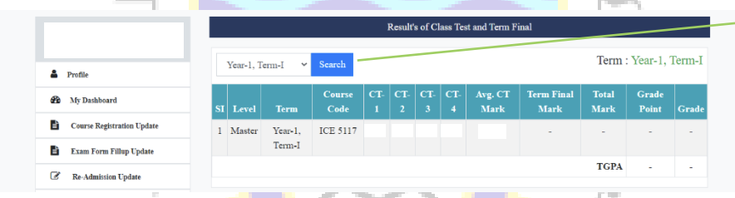

**When click class schedule in student dashboard**

This page will open

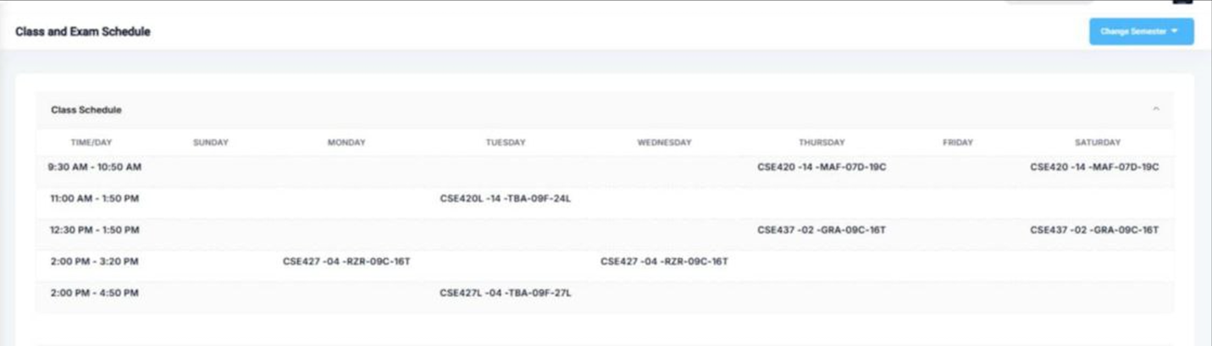

**When click exam routine from student dashboard**

This page will open

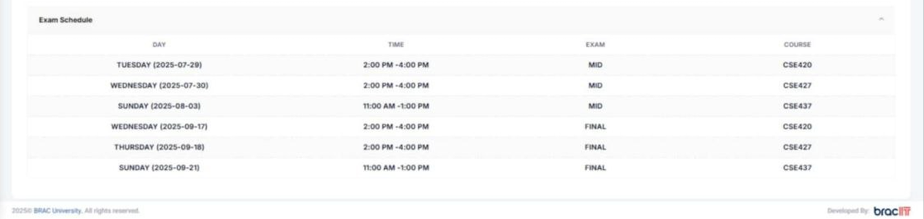

**When click Exam routine from student dashboard**

This page will open



**When click syllabus from student dashboard**

This page will open

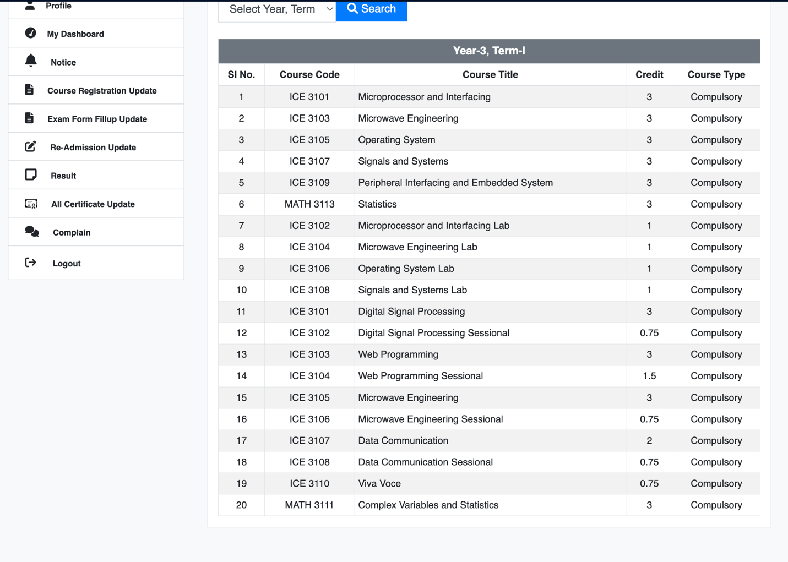

**When click Curses from student dashboard**

This page will open

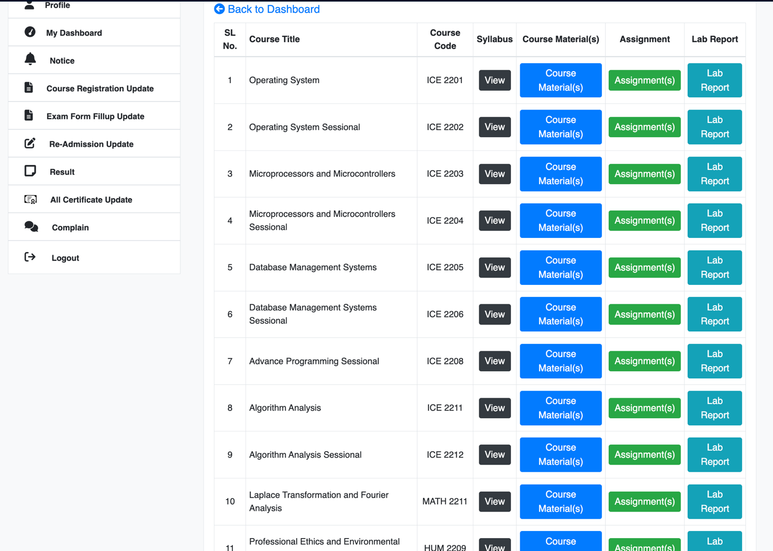

There are a lot of buttons like this and I’ll design them like the page I’ve added here.

In teacher’s and CR’s section they can upload pdf, pictures, and marks of exams and will be assignment hand-in, hand-out options there.

For teachers dashboard,

**When click Upload Ct result**

This page will open

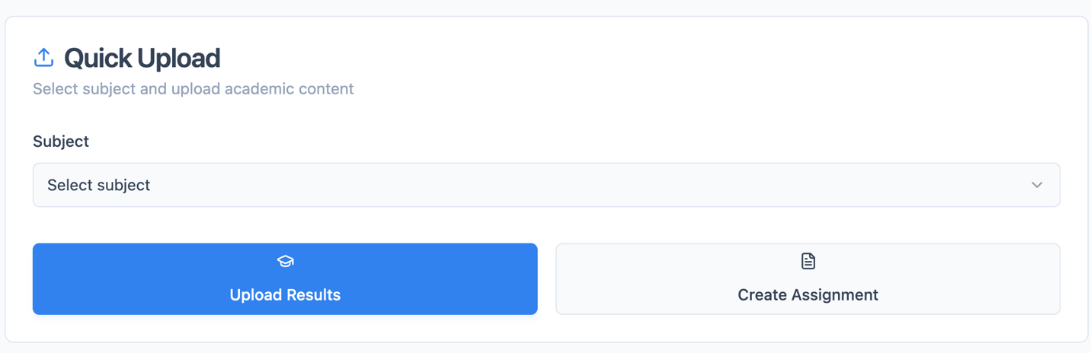

For teacher’s there will be multiple button like this to upload marks or to view routine and many more.

For CR’s dashboard,

**When click upload class Routine**

This page will show

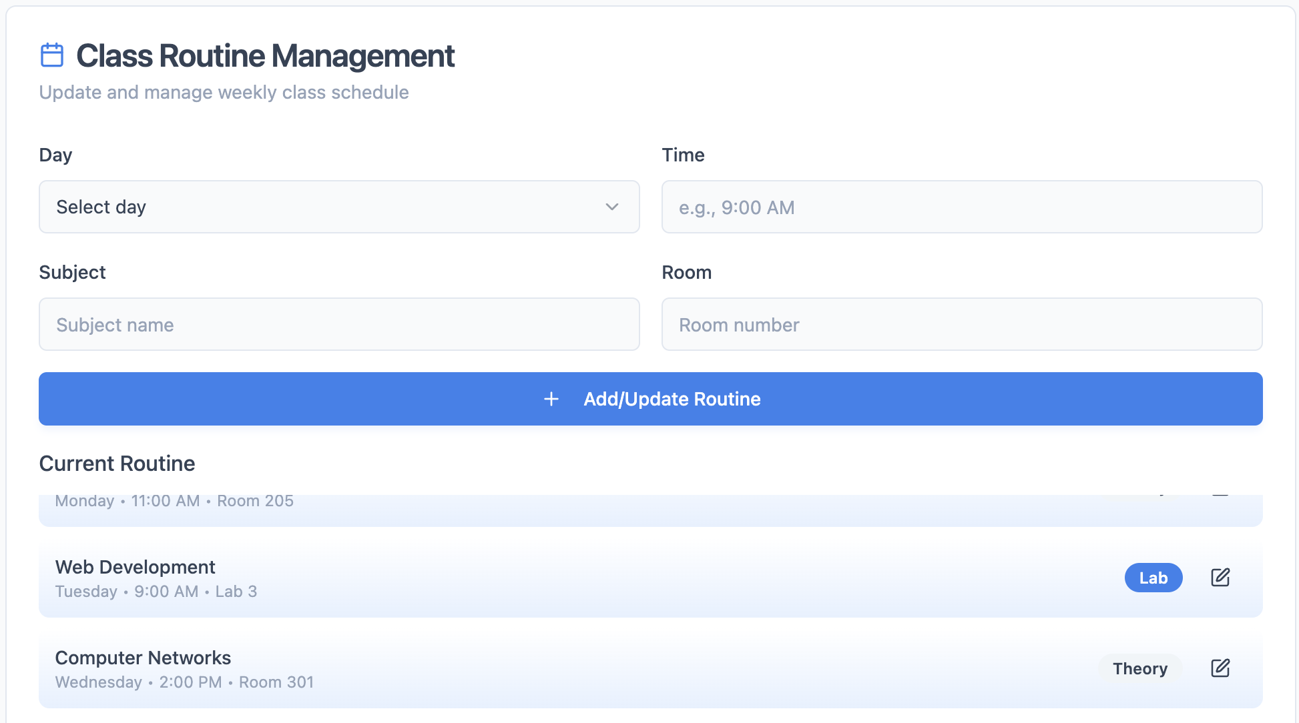

Cr’s can Upload Notices like this :

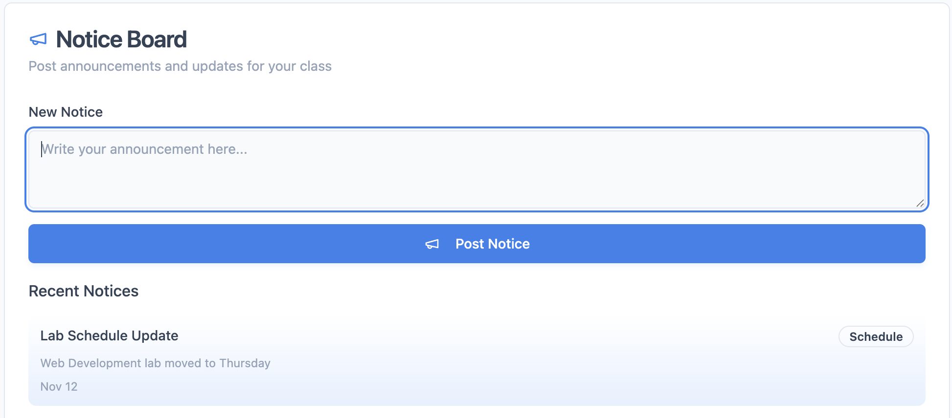

This document presents an overview of the core components and user interfaces of the departmental portal. It highlights the major sections and demonstrates how students, teachers, and class representatives (CRs) will interact with the system. However, As the project progresses, enhancements and additional features will be introduced to improve usability and ensure a more comprehensive academic experience. All future elements will maintain consistency with the current design and purpose illustrated in this documentation